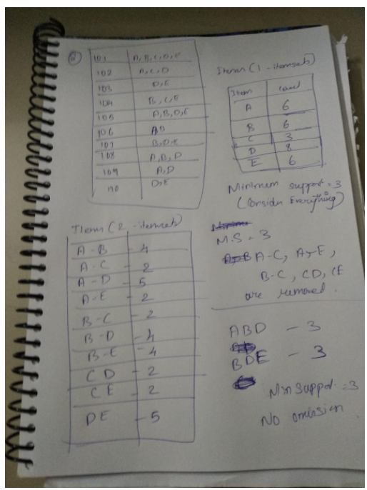

install.packages("arules")

data <-read.transactions(file = "V:/DataScience_2019501043/Data_Mining/Final_exam/aprori.csv",sep=",")

data

#support = How many times to (A,B) occur in all the 10 rows

#confidence = If(A,B) occur what is the probability to get C

rules <- apriori(data,

parameter = list(support = 0.01, confidence = 0.2))

#rules <- apriori(data)

inspect(rules[1:80])

rules_by_lift <- sort(rules, by = "count")

#We sort it and we display till 3

inspect(rules_by_lift[1:21])

